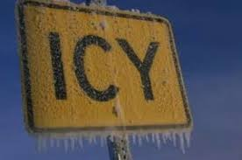

Stay off the Roads Before the Weather Gets Bad

As we prepare for another possible ice storm, Prince William County Department of Fire and Rescue (www.pwcgov.org/fire) urges residents to stay off the roads. If you don’t have to travel, don’t! The safest place during a winter storm is indoors. But, if travel is unavoidable, be prepared for the worst. Would you know what to do if you became stranded while traveling in your vehicle? According to the National Weather Service, the majority (70%) of snow and ice related fatalities occur in automobiles and approximately 25% are people caught off guard, out in the storm.

“Stay off the roads when weather becomes treacherous, states Prince William County Fire and Rescue Chief Kevin McGee. Help Us, Help You, by staying off the roads, to keep the roads clear of traffic and traffic incidents enabling fire and rescue personnel to promptly respond and assist residents who are in dire need of emergency care and services.“

Help Us, Help You!

